**Shubham Vivek Reddy**

**CONTACT NO.** : 9172587538/9960235754

**E-MAIL ID**: shubhamreddy9172@gmail.com

**OBJECTIVE**

Seeking an opportunity to obtain and secure position that will enable me to use my organization skills as well as my ability to work well with people. I want to work in suitable environment that would challenge my technical skills and give me direction.

**EDUCATIONAL QUALIFICATION**

|  |  |  |  |  |
| --- | --- | --- | --- | --- |
| **DEGREE** | **Board/ University** | **Year** | **Percent-age** | **School/College** |
| DIPLOMA  (Civil.Engg) | MSBTE | 2019-20 | 86.00% | P.L.G.P.Latur |
| S.S.C | State  Board | 2016-17 | 87.60% | Shree Ganesh Vidyalay, Latur |

.

**COMPUTER SKILLS**

* MSCIT
* Android Studio
* Core Java, Advance Java
* C, C++
* Java Script, PHP

**EXTRA CURRICULAR ACTIVITIES**

* Participated and got Scholarship in Maharashtra state council of examination (Scholarship).
* Participated and got Scholarship in National Means-Cum-Merit-Scholarship.
* Participated and got Scholarship in MTS (Multi-tasking staff).
* Participated in Intermediate Grade Drawing Examination.

**PROJECT**

* Diploma Project:

Title- Safety Precautions taken during construction of building

**HOBBIES AND INTERESTS**

Teaching

Drawing, Dancing

Acting

**STRENGTHS**

* Ability to grasp ideas & put them to practice.
* Eager to learn new things.
* Open-mindedness**.**
* Quick Learner.
* Punctual.

**PERSONAL INFORMATION**

**Name :** Supriya Santaji Patil.

**DOB :** 16th January 2002.

**Languages :** English, Hindi, Marathi.

**LinkedIn :** supriyapatil3152@gmail.com

**Permanent Address :** A/P K.Tadwale Tq.Dist-Osmanabad,413501.

**DECLARATION**

I declare that above mentioned information is correct and true to the best of my knowledge.

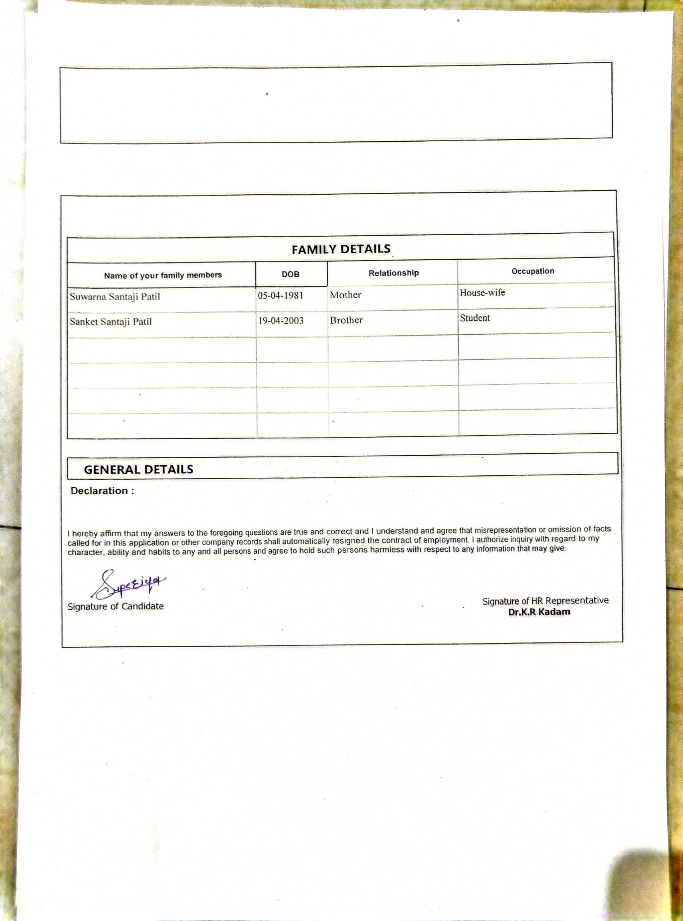Place:Latur

Date:17-03-2020

**Supriya S. Patil**